**ACTIVITY 1**

1. Open index.html on **Chrome**
2. Open the “**Elements**” tab of the developer’s tools (Ctrl + shift + I)

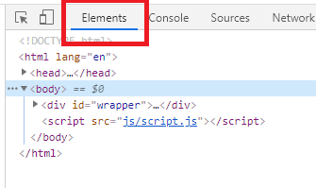

1. Answer the following questions and **return your word documents on telegram**:

Q1 – How many children has the element with id **add-book**?

ID add-book has six children.

Q2 – What is the **parent** of the element h2 “book to read”?

The parent of the element h2 “book to read” has noe.

Q3 – What are the ID and CLASS of element used for?

ID and CLASS of the element used o cature all the elements of the ID.

Q4 – Select the <div> of id “book-list” and delete it. What happens?

Missing these items.

